**An Android POS Application for Menu-Based Suggestions using ECLAT Algorithm**

A thesis-equivalent master’s project presented to the

Department of Computer Science

University of Nebraska at Omaha

In Partial Fulfilment of the Requirements for the Degree

**March 29, 2015**

**SUPERVISORY COMMITTEE**

Dr. Zhengxin Chen (Chair)

Dr. Sanjuktha Bhowmick

Dr. Sajda Qureshi

**PREPARED BY**

Murali Krishna Reddy Survi

# Abstract

In today’s world of a myriad businesses, which offer to service customers in all possible ways, a point-of-sale application has almost become indispensable for daily transactions for the customer community. With improving technology, point-of-sale applications that was initially used only to bill customers, now come with a variety of features that are of immense assistance to customers. My project considers point-of-sale applications in a very popular business – “restaurants.” While POS applications might be a commonplace visual in restaurants, what they lack today is the ability to provide “menu-based suggestions” to customers. A customer who is new to a restaurant might want to know the most popular food items before placing an order. My project plugs this void in today’s restaurant-based POS applications. This can be achieved if the concept of data mining is used in a POS application. Going forward, the combination of data mining and POS applications can even prove to be the management’s business strategy advisor by pointing out to them the food items that made great business and those that have not resonated with the customer base.

Data mining, in the recent past, has proved itself to be a promising computational process of reporting critical data patterns for almost every organization regardless of its functional domain. Association rules, a tremendously popular dimension of data mining, can be invoked to extract menu-based suggestions from real-time business transactions that happen in a restaurant. After some research on widely known association rule mining algorithms, I chose ECLAT algorithm to generate menu-based suggestions.

**Key Words:** Menu-based suggestions**,** association-rule mining, ECLAT Algorithm,

# Dedication and Acknowledgement

I pick this moment to acknowledge my immeasurable pleasure and gratification of being associated with this intellectual endeavour of unleashing a never-before-introduced POS Android application. I especially feel jubilant as I could implement the concepts I absorbed over the last two years of my master’s coursework into a real project that also helped me exercise my grey cells.

I would like to extend my sincere thanks to my supervisor Dr. Zhengxin Chen for his assistance that helped my project progress in leaps and bounds. I also thank my committee members Dr. Sanjiktha Bhowmick and Dr. Sajda Qureshi for their timely advice and their tremendous guidance that led to the completion of my project.

I would also like to thank the professors of the Department of Computer Science at University of Nebraska at Omaha who taught me a plethora of courses. The hands-on experience I gained during my coursework catalysed the completion of my project.

Most importantly, I would like to acknowledge my love and gratitude to my parents and friends who have been an unflagging source of moral support and inspiration.

Contents

Abstract 2

Dedication and Acknowledgement 3

1. Introduction 5

2. Literature survey 8

3. Methodology 21

4. Project Implementation 24

4.1 Block Diagram of Project 24

4.2 Process Flows 25

4.2 Modules 26

4.2.1 Openshift JBoss Server Setup Module 26

4.2.2 User Management Module 27

4.2.3 Order Management Module 27

4.2.4 Menu-Based Suggestions Using ECLAT 28

4.2.5 Testing and Dataset creation 28

4.3 Dataset 29

4.3.1 Database Schema 30

5. Results 37

6. Limitations 50

7. Development Environment 51

8. Future Work 52

9. Conclusion 53

10. Reference 55

Table of Figures

**Figure 1: Prototype of the to-be system** 21

**Figure 2: Block Diagram of the project** 24

**Figure 3: Process Flow of the to-be system from customer’s perspective** 25

**Figure 4: Process Flow of the to-be system from management’s perspective** 26

**Figure 5: Database Schema** 30

# Introduction

The invention of technology has revolutionized the world and the way we perform our daily chores. Technology continued to become smarter with every passing day and this led to the evolution of mobiles and tablets in all spheres of life. Though the implementation of technological know-how has been ubiquitous, I felt there is scope for more technological penetration in the dimension of point-of-sale applications. Point of sale (POS) software is undoubtedly a part of the commercial business these days, but I strongly believe that overhauling the way the existing POS systems work in business can work wonders for both the customer base and the management driving the business. Despite offering a plethora of services to customers these days, a POS system in restaurants stands crippled when it comes to making food or menu-based suggestions to customers.

It is an absolute regular sight to see customers handling POS applications in restaurants to make transactions, to check out food items on the menu and even to place orders on the application itself sitting right in the comfort of their chairs. In order to boost the sales of a restaurant the best strategy is to enhance the service a POS application can do to a customer by using a data mining algorithm. In addition to just viewing the menu, ordering food and paying his bill, a customer will even want to know the food items that are always in demand and have been given many thumbs-ups so he knows what food to elect. Secondly, a customer, who is trying a new cuisine and has chosen one food item, might want to seek suggestions on which other food item goes best with the one he has chosen. And thirdly, a customer, as he opens up the menu, might wish to view a laundry list of suggestions on the various combinations of food which a preponderance of customers have found delicious.

Customers will undoubtedly appreciate such menu-based suggestions that will make their lives easier. The best part is that such menu-based suggestions are credible as they have been derived by effective data mining algorithms based completely on the previous transactions made by customers in the past. Besides this, rolling out such a feature to customers will inarguably augment sales and record profits for the management. In short, it turns out to be a win-win for both the customers and the establishment’s management.

The heads of the business using the application can get a better insight into sales data – what kind of foods are in demand, what are the areas of improvement the business should now focus on, and the buying habits of the customers. The manager can tweak his business tactics in accordance to the analysis he makes using the application.

Such a POS application, which my project aims to construct, is an out-and-out novel and never-before-introduced system. The fact that there has been no concrete resources viz., peer-reviewed papers, publications, journals or books that claim the existence of a food-suggesting POS system in restaurants, makes my project creative, innovative and new.

Having mentioned what is present in the POS system today, and what needs to be added to make it flash menu-based suggestions, the next logical step is to home in on an effective association rule mining algorithm that can do the trick for us. After some research on existing algorithms, the notable ones are Apriori, FP-growth and ECLAT.

The Literature Survey I made gives an in-depth understanding on all the above-mentioned algorithms and why I plumped for ECLAT. I conducted sufficient analysis and research, read peer-reviewed papers and rummaged through books on association rule mining in order to lay out the merits and demerits of each of these algorithms (along with their respective variants). After weighing all the pros and cons, I finally chose ECLAT as my potential candidate algorithm for bringing out menu-based suggestions in restaurants.

The crux of my application is displaying menu-based suggestions powered by the ECLAT algorithm, a powerful data mining technique, used to identify or discover frequent patterns among itemsets. The goal is to establish the items bought together by studying customer carts (also called market baskets). Once these patterns are uncovered, they help us extract something called association rules among item sets. Association rules give us more clarity on how probable are items to co-appear in a market basket. An example of an association rule can be: “Customers who buy a laptop tend to buy a wireless mouse and a headset.”

While the algorithm is in place, we need a database with which our application has to communicate. This database is consulted by our algorithm and analysed to create a dataset which is in turn analysed for identification and reporting frequent patterns. The database in question is being stored on a cloud and is contacted by the frontend using RESTful webservices.

# Literature survey

A point of sale application is deployed in many a retail business these days to facilitate easy completion of transactions for the customer fraternity. The application is called so as it is the point where a customer makes his or her payment to the business establishment for the goods purchased. With technology recording progress in leaps and bounds, the services a point of sale application doles out to the customers varies from business to business. For e.g., in a retail store like Target, a point of sale application might permit customers to pay for the goods purchased by them or to return payments for the items returned. Likewise, a bar may use more customized software to cater better to the needs of special orders. Similarly, a grocery store will make use of weighing scales to weigh the quantity of fruits or vegetables purchased.

Narrowing down our scope to the usage of point of sale applications in restaurants, numerous hand-held PDAs (may be touchscreen) and one master server computer comprise the arrangement of a point of sale application in most restaurants. Key market players like Micros, Squirrel and Ibertech constantly endeavour to outsmart each other by adding a slew of technical and technological amendments. In most POS applications, the commonly found features are:

* Constant updates to menu depending on the availability of items (or simply, ‘menu tracking’)
* Enhanced graphical user interface to simplify ease of use
* Ability to track the duration to serve the meal or service timing
* Reporting capacities to help support management’s analysis and business strategy formulation
* Upgrading a hand-held device to accommodate touch screen and voice recognition
* Opportunity to allow restaurant’s operation management to decide what equipment to purchase to better serve the customer base (Ansel & Dyer, 1999)

The crux of any POS application is ‘constant menu tracking.’ Let us now analyse how this is achieved. The master copy of the restaurant’s menu is stored on the server. Any updates or changes to the menu are firstly done on this master copy and these changes are immediately cascaded to the hand-held devices arranged on various tables in a restaurant. At any point of time, it is ensured that copies held by the hand-held units and the main master menu are in sync. As and when orders are placed by customers, the quantity remaining of any particular food item is duly updated and these updates are reflected forthwith in the hand-held units. So it goes without saying that whenever the quantity of a food item, owing to many orders, reaches a nought, any further orders on that item are summarily rejected by the system. In addition, a waiter has the ability to print out an order for a customer or sometimes the customer can himself print out a paper copy of the bill (Jones & Palvia, 2004).

After my research on the array of features available in most POS applications today, I felt that while these applications already offer a string of services to customers, they often lack what I call ‘intelligence.’ Intelligence in this context is intelligently suggesting foods to customers.

***I put this on record that there are no proper or pronounced resources available on the internet or in books, journals or publications that prove the existence of menu-suggesting point-of-sale applications in restaurants. This plug-in I am developing that is ready to be rolled out for restaurants stands out as the whole and sole achievement of my master’s project.***

While constant menu updates are reflected in a split second and making transactions has become a lot easier, I felt the application does not suggest food items to the customer using the hand-held device. Many a time, a customer might feel the need for knowing what food items a restaurant is famous for before placing an order in the hand-held device. Besides, there might also be a scenario where a customer chooses a food item but does not know that his experience will be delightful only if he would choose another item which makes his meal complete. A new customer might also want to know the list of combinations of foods that have been relished and given thumbs-ups by a majority of customers. Today’s POS applications do not seem to offer these suggestions that might make a customer’s experience with food much more pleasant. Such a feature, if included, in the POS applications will eventually offer a hand of help to the management by giving it the ability to evaluate which foods are drawing crowds and which are not. This ‘gap,’ is something I always wanted to fill via my project.

Having understood the void I wanted to work on, the next obvious and logical step to it is to understand how to do it. “Association Rule Mining” was the undisputable answer.

The realm of Association Rule Mining presents the typical tech-savvy customer and business quarterbacks with a suite of data mining tools and techniques to make more pragmatic and profit-driven business decisions. The motivation behind mining data is to observe customer buying patterns which are in turn used to zero in on the right marketing and customer support strategy. Most commercial organizations, to bump up their sales by studying customer behaviour, resort to data mining techniques like cluster detection, memory-based reasoning, market basket analysis, genetic algorithms, link analysis, decision trees and neutral nets (Berry & Linoff, 1997).

To reiterate, association rule mining is all about mining frequent patterns in transaction databases, time-series databases and the like (Han, Pei & Yin, 2000). In order to accomplish the task of generating menu-based suggestions, I understood that leaning on association rule mining algorithms can be a smart strategy. Out of these, Apriori, Frequent-Pattern growth, ECLAT algorithms are the notable ones.

In order to zero in on an effective and efficient algorithm that can manufacture menu suggestions in the way we desire, thorough research, analysis and understanding on the above-mentioned algorithms is needed. The sections that follow present these algorithms in great detail.

Even before we weigh the pros and cons of each of these algorithms, let us mention the notion of a candidate set. A candidate set is a potential set of frequent patterns from a datawarehouse. While candidate set generation is the crux of Apriori algorithm, it has been proven that it is an obstacle to good performance in terms of space and computational power (Malhis, Ruttan & Refai, 2005).

In order to rise above these infirmities of Apriori algorithm, other algorithms have chosen to do away with candidate set generation. For e.g., in order to achieve high performance and efficiency, the FP-growth employs the three-point formula: a) compression of a large database into a small data structure thereby avoiding redundant scans b) adoption of a pattern fragment growth method dispensing with candidate set generation and c) divide-and-conquer strategy to mine confined patterns in designated databases that diminishes the ambit of search (Han, Pei & Yin, 2000).

Let us now discuss the concept of association rules among item sets in large databases. The word basket data has been coined to refer to data that contains items purchased on a per-transaction basis. Now, this basket data is built over time and not overnight. It may not contain items bought at one point in time, but it may contain items purchased by a customer over a duration of time (Agrawal, Imielinski & Swami, 1993). The *support* of an itemset in a transaction is the percentage of all transactions containing the itemset. An itemset is large if its support is greater or equal to a user-specified support threshold. Otherwise it is small. If X=>Y is an association rule, support is X U Y. The *confidence* is the percentage of transactions containing X that also contain Y. For any association rule to hold good, it must have a support greater than or equal to a user-specified support threshold and a confidence greater than or equal to a user-specified confidence threshold. Existing algorithms like Apriori follow a two-point agenda to compute association rules:

1. Locate large itemsets
2. For each large itemset Z, find all subsets X, so that the confidence of X=>Z \ X is greater or equal to the confidence threshold (Hidber, 1999).

This is predominantly used to solve data mining problems one of which is the problem of establishing association rules in a basket data. The Apriori algorithm studies a basket of data sets, where each data set contains a set of items, and zeroes in on the combination of items that occur frequently. If there exists a store with |I| items and assume that *b* shoppers have one basket each. Each shopper shops a set of items for their basket. A list comprising the contents of each basket is the input fed into the Apriori algorithm. Assuming that *k* is a fixed threshold, the algorithm outputs a list of item sets that are frequent. In other words, these are the items that come up in at least k of the *b* baskets.

The Apriori algorithm, being a level-wise algorithm, considers item sets in the order of their size. This means that the sets of size one are tested first if they come up in k baskets, then sets of size two are considered and the process goes on. So at every level, the algorithm is aware of the result of the previous level. The core concept of this algorithm is that at any level, say l, a set is tested if and only if all its subsets of size l-1 are frequent. An item set that satisfies this concept is called a candidate at level l. It is a success at level l if it is contained in at least k baskets and it is a failure otherwise (Purdom, VanGucht & Groth, 2004).

An addition to the Apriori algorithm, BruteSuppression, is known to reduce the size of extremely large rule sets and therefore save time for the user to interpret the results. This size reduction is achieved by discarding overlapping rules. Digging a little deeper into this, a rule set may contain hundreds and thousands of rules. Such high sizes of rule sets can decrease the comprehensibility of the data set being analysed. The Brute Suppression proposes reduction of the rule-set size by eliminating rules that overlap with other rules. The overlap between rules is assessed using a measure based on suppression (Gebhardt, 1991). The critical concept in this algorithm is that if two rules bear close resemblances, it is safe to delete one of them (Reynolds & de la Iglesia, 2006). It has been proven by Reynolds and de la Iglesia in 2006 that two semantically different rules cover the same set of records. On the flip side, if a rule uniquely covers a set of cases, it is advisable to retain it despite it having a lower support and confidence than other rules in the rule set (Hills, Bagnall, de la Iglesia & Richards, 2013).

The main demerit of the Apriori algorithm is wastage of time in holding an avalanche of candidate sets with frequent patterns. It can even suffer from low minimum support and large itemsets. For example, if there are 10^4 candidates from frequent 1- itemsets, it needs to generate more than 10^7 candidates into 2-length which in turn will be tested and accumulated (Rao & Gupta, 2012). Additionally, to detect frequent pattern in a size of 100, it has to generate 2^100 candidate itemsets (Wu et al., 2007) that lead to expensive transactions and wastage of time in candidate generation. In order for these search operations, Apriori will have to conduct redundant scans in the database which turns out to be quite an overhead. Thus an Apriori can result in low efficiency and performance (Al-Maolegi & Arkok, 2014).

Having discussed the improvements made to Apriori via the BruteSuppression and Improved Apriori, let us also discuss the bottlenecks these two algorithms suffer too. Though it has been proven that removing overlapping rules from Apriori rule sets decreases the size of the rule sets it cannot be considered a gospel. It cannot be called an ideal method to reducing the size of every rule set (Hills, Bagnall, de la Iglesia & Richards, 2013).

Likewise, the Improved Apriori, though makes a claim of reducing time by about 67%, still continues to make multiple database scans to find frequent itemsets.

My research into the available suite of algorithms that reduces the time and space complexity continued until I hit upon the FP-growth algorithm. The next few paragraphs present my understanding on it.

**FP Growth Algorithm:**

FP Growth Algorithm is considered a fast algorithm for frequent item set mining. The nucleus of the FP-growth algorithm is a data structure called FP-tree. This FP-tree is used to save significant quantum of memory for storage of transactions. The basic steps of an FP-growth algorithm are:

1. The fundamental notion on which the algorithm works is a recursive elimination scheme. By virtue of this scheme, in the preprocessing step, all transactions that are visibly infrequent and do not appear in the user-specified transaction threshold are to be deleted.
2. From among these, all transactions containing the least frequent item are to be relieved of this item. Repeat the process to obtain a reduced or *projected* database. All the item sets found in this process of recursion share the deleted item as a prefix.
3. Next, upon return, the processed item also is to be eliminated from the database of all transactions and the process is restarted. The second frequent item is processed and so on.
4. In due course of this process, the prefix tree, which is gains size by the links between branches, is used to quickly find transactions containing a given item. In addition, it is also used to delete this item from the processed transactions.

Quite a few variants of the FP-growth algorithm surfaced over time, one of which is C implementation of the FP-growth algorithm. This makes considerable changes to the existing algorithm in order to enhance the performance and make cost improvements to the FP growth algorithm.

The algorithm at a high-level:

1. Preprocessing: The preprocessing step makes an initial scan to find out the frequencies of the items in the database. This includes the support of single element item sets too. Another part of this step includes removal of infrequent items – all items that do not appear in many transactions are summarily discarded as they cannot be a part of the frequent item sets. All items in each transaction are sorted in the descending order with respect to their frequencies. Experiments have time and again proved that sorting them in the descending order of frequencies results in a much shorter execution time as opposed to a random order. An ascending order of items will result in a much slower execution time.
2. Building the Initial FP-Tree: After the elimination of the infrequent items from the database, it transforms itself into an FP tree. This tree is predominantly a prefix tree, i.e., each path in the tree denotes a group of transactions sharing the same prefix while each noted in the tree represents one item. All nodes talking about the same item are strung together in one list. This is done to aid any possible search operation for an item in this list. Each such list can also be accessed using a root element that also holds the count of occurrences of the item in the database.
3. Projecting an FP-Tree: The critical step in the FP-growth algorithm is to construct an FP-tree out of a projected database. A projected database is a database comprising transactions containing a desired item, with this item deleted. This projected database is recursively processed, the caveat being all the frequent item sets found in the recursion share the deleted item as a prefix.
4. Pruning a Projected FP-tree: Having obtained an FP-tree of a projected database, additional pruning might be carried out with an intention of simplifying the tree and catalyzing the projections. A potential pruning technique can be α-pruning. Consider an FP-tree that resulted from a projection and that the minimum support is 2. An infrequent item, say I, is not needed in projections, but can give rise to branching in the tree. So the removal of this item results in simplification of the tree and this simplified tree can be turned into a simple list (Borgelt, 2005).

Other popular variants of FP-growth include COFI-Tree and CT-PRO. Having discussed the FP-growth algorithm at length, it is quite evident that it is a highly performant algorithm. The only bottleneck that I could analyze is that the frequent item sets are repeatedly and recursively mined. In other words, multiple database scans are launched. For large databases, the structure of an FP-growth and all its variants does not seem to be a good fit into the main memory. This is primarily because a large database would warrant the construction of a large FP tree and this hits the processing speed as well (Gupta & Garg, 2011).

**ECLAT Algorithm**

ECLAT program is a depth-first-search algorithm used to mine frequent itemsets. It is particularly developed to identify critical buying patterns of customers and to enhance the process of strategic decision making like market-basket analysis, cross marketing and promotion assortment (Saxena & Gadhiya, 2014).

It aims at fishing out frequent patterns of data chosen by the customers of supermarkets, mail-order companies and online shops. This frequent pattern is called association rules where we make some kind of conclusion about the probability of two sets of items to co-occur (Zaki & Meira, 2014). The approach to discover such association rules mainly revolve around establishing relationship between items based on customer buying patterns (Saxena & Gadhiya, 2014). This is used in many application domains. Once these credible and potentially useful patterns are uncovered, it is used to give hints about the products to customers or may be to suggest products to customers. However, frequent item set mining may be used for a much wider variety of tasks, which share that one is interested in finding regularities between variables in a given data set. Eclat algorithm does not require candidate generation (Vijayarani & Sathya, 2013).

**Key concepts vis-à-vis ECLAT**

Let items I = {x1, x2… xm} and set X ⊂ I is called an itemset. In this project, the set of items I denotes the collection of all menu items in a restaurant. An itemset of size k, is called a k-itemset. Let I(k) denote the set of all k-itemsets, i.e., subsets of I with size k. Let *T* = {t1, t2… tn} be a set of transaction identifiers, also called tids. A set T ⊂ *T* is called a tidset. It is assumed that itemsets and tidsets are kept sorted in an alphabetical order.

A transaction is a tuple of the form <t, X>, where t ∈ T is a unique transaction identifier. In this project, the set of transactions T denotes the orders placed by customers in a restaurant with various menu items.

The following diagram shows a sample database D with six transactions and five items. These are divided into tidsets.

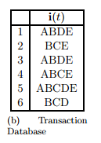

**An example database**

The support of an itemset X in a dataset D, denoted sup(X, D), is the number of transactions in D that contain X. If sup(X, D) >= minsup (Minimum threshold support) then the itemset X is a frequent pattern.

While calculating frequent itemsets, we need to calculate all possible subsets of items I, which are called candidate itemsets and each candidate itemset has to be scanned against the entire database. This proves to be a very costly operation. ECLAT algorithm helps reduce the generation of candidate itemsets and in turn reduces the I/O operations i.e., the number of database scans.

**The ECLAT Algorithm – Tidset Intersection Approach**

ECLAT algorithm uses two basic principles.

1. If an itemset X is frequent, then any subset Y ⊂ X is also frequent and if X is not frequent, then any superset Y ⊇ X cannot be frequent.
2. The support of a candidate itemset can be computed by intersecting the tidsets of suitably chosen subsets.

Step 1: Prune the generation of non-frequent itemsets and step 2 eliminates the multiple database scans.

**Algorithm:**

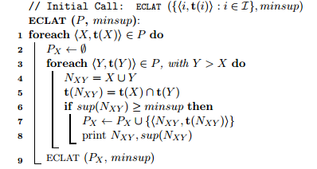

The initial call is with all the single items along with their tidsets. A tuple of the form <X, t(X)> can be called an itemset-tidset pair (IT-pair). In each recursive call, ECLAT intersects each IT-pair <X, t(X)> with all the other IT-pairs <Y, t(Y)> to generate new candidates NXY. If the new candidate is frequent, it is added to the set PX. A recursive call to ECLAT then finds all extensions of the X branch in the search tree. The process continues in a DFS manner until all frequent sets have been found.

The computational complexity of ECLAT is O(|D| * 2|I|) in the worst case. In practice, it is very efficient, since support is directly obtained by fast intersection operations. If t is the average transaction size, and if ‘l’ is the longest frequent itemset, the computational complexity is close to O(t * 2l). The I/O complexity of ECLAT is hard to characterize, since it depends on the size of the intermediate tidsets. Also due to the DFS search, as soon as the IT-pairs fit in memory no further database scans are required (Zaki & Meira, 2014).

**Why ECLAT?**

After presenting my research about Apriori, FP-growth, their variants and ECLAT, and after thorough understanding of the pros and cons of each of these algorithms, I chose ECLAT, over the other two, for the implementation of the menu-based suggestions I contemplated to be deployed onto POS devices. This is because an ECLAT algorithm makes just one database scan to stash the frequent mining patterns, but Apriori and FP-growth make numerous database scans for finding out frequent item sets. Additionally, an ECLAT algorithms avoids the unnecessary candidate set generation that turns out to be time consuming and costly while Apriori and FP-growth spend quite a few resources on generating thousands of candidate sets, some or most of which might not be necessary for the final frequent pattern itemset generation.

As my application will be deployed on to mobile-like devices or tablets, where the memory and processing power, both, are limited and constrained, it is obvious that the number of database scans and the processor overhead should be as low as possible. We need to scrimp and save on the processor time and power and avoid unwarranted candidate set generation and also bring down the database scans to as minimal as possible. All these three pressing reasons prompted me to summarily choose ECLAT algorithm for menu-based suggestions.

# Methodology

To reiterate, the gap in the current POS application systems in the field of restaurants is that they do not seem to be offering any menu-based suggestions to customers on what food items to order. Suggestions on popular food combinations is what I seek to add to the suite of services a POS application provides.

In order to achieve the goal of injecting menu-based suggestions into a restaurant-based POS application, I worked to unleash a prototype of the system I envisioned. The prototype I came out with is shown below:

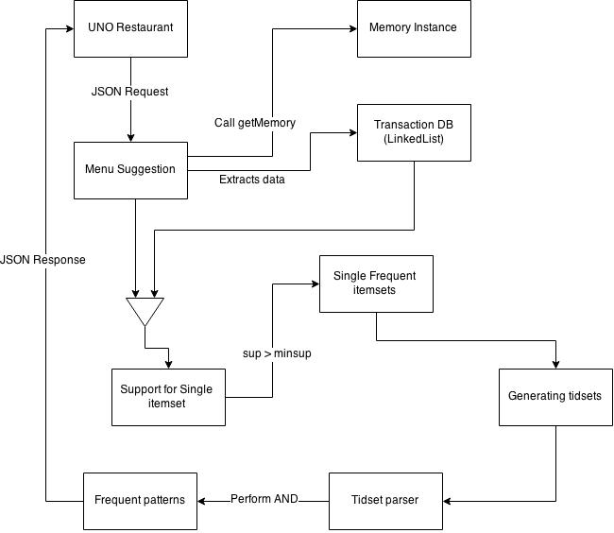

**Figure 1: Prototype of the to-be system**

The UNO Restaurant is the POS application that is running on the hand-held device. This, in order to generate the menu-based suggestions, makes a JSON request (consists of a date range and minimum support) to the Menu Suggestion Class. This class calls a memory instance class which in turn calculates the memory utilized for generating menu-based suggestions. The Menu Suggestion Class calls the Transaction Database simultaneously to extract data and to store this extracted data on a linked-list. This call to the database accounts for one database scan and the next step in the process is to calculate the *support* for the single item set. This calculated support should be greater than or equal to a preconceived support threshold and if it is greater than this, all the single frequent item sets are stored on an array list. Using this frequent item sets, *tidsets* are generated and are pulled into a parser which creates a candidate set using the existing *tidsets* and moves ahead with performing an AND operation. The output of the AND operation is a fully calculated *support* which is again ensured to be greater than the minimum *support*. Once this check is completed, all the fished out menu-based suggestions are sent to the UNO Restaurant application via a JSON.

In order to test the ability for menu-based suggestions, the existence of a dataset is imperative for the database to exist and to be scanned for frequent item sets. Since a transaction database is confidential information for any commercial establishment and it cannot be found online or gathered by research, I manually created transactions and inserted them into the database. To accomplish this, I created an Order Management System to accommodate manual inserts into the database.

This manually created transactional database will be the resource from which frequent item sets are generated. The results of this cardinal operation are shown in the results section.

Next, to test the application, which already consists of around 150 transactions in the database, I crosschecked if the menu-suggestions the application was showing indeed matched with the frequent items in the database. The frequent food items in the database did actually match with the menu-based suggestions my application was making. Also, my other test cases included verifying the menu suggestions against the actual values with various *support* threshold values and for several date ranges.

# Project Implementation

## 4.1 Block Diagram of Project

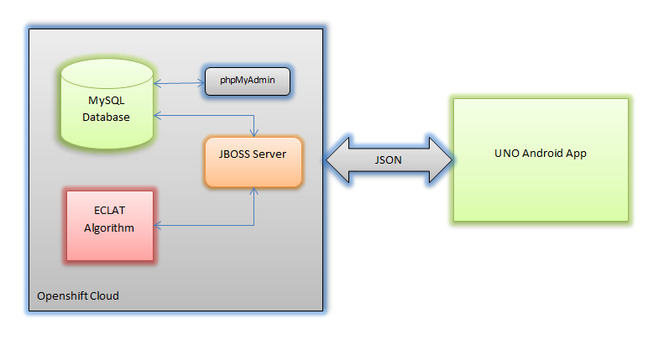

**Figure 2: Block Diagram of the project**

Figure 2 illustrates the overall architecture of the project. Customer or manager has to install the UNO Restaurant Android Application on to tablets. All the requests from the application are communicated to the Openshift JBoss server through HTTP requests using JSON. JBoss server hosts webservices which serve all the requests coming from the application. JBoss server is able to communicate with MySQL databases on the cloud to perform various select, delete, insert and update operations. Apart from the database, it can create a customized dataset from the database and sends it to the ECLAT algorithm for menu-based suggestions. ECLAT algorithm mines the data provided by server for interesting patterns and sends these suggestions to the application. For every request sent from the application, JBoss server sends a response that has to be consumed by the application.

The Database Administrator is the only user who can access the database directly using phpMyAdmin to manage and maintain the database. He has the prerogative to add managers to the application.

## 4.2 Process Flows

A flow chart for the process flow of the application created is shown here. This explains a step-by-step procedural flow of obtaining menu-based suggestions and order management for a potential customer.

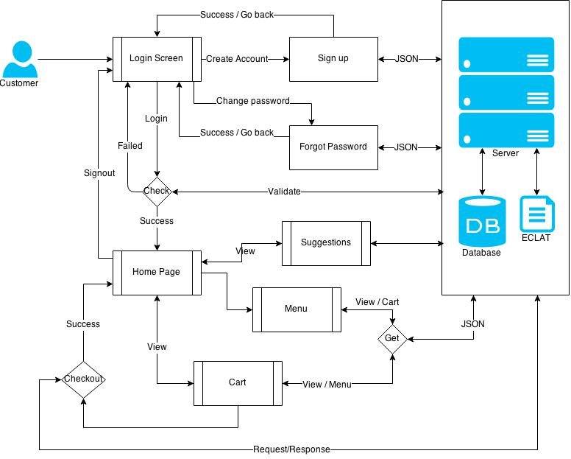

**Figure 3: Process Flow of the to-be system from customer’s perspective**

This explains a step-by-step procedural flow of menu tracking for a potential manager.

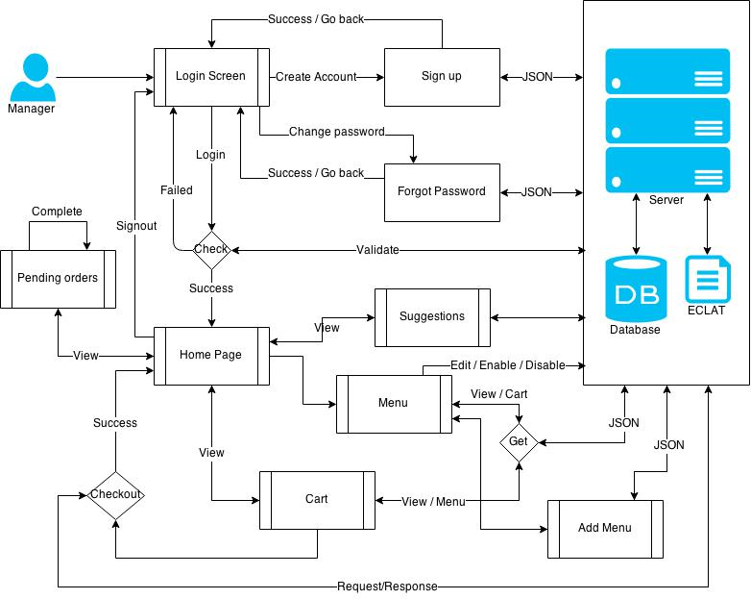

**Figure 4: Process Flow of the to-be system from management’s perspective**

## 4.2 Modules

This section demonstrates how each module is developed and what programs are used in order to achieve the functionality of each module and how the final application and backend server have been created.

### 4.2.1 Openshift JBoss Server Setup Module

After days of research into cloud storage media, I found Openshift cloud storage to be the best open source webserver as it allows me to host my webservices and store my data in a MySQL data. I installed Openshift plugin on Eclipse and created a project titled “Webservice” that in turn allows creation of webservices through J2EE. Then I designed a database schema satisfying the Third Normal Form to store complete restaurant information like menu, orders, users, and so on.

### 4.2.2 User Management Module

In this module, I developed SignUp.java on the server side which creates RESTful webservices using JSON for login, account creation, resetting password, forget password. These webservices communicate with the database to perform insert, delete, update and select operation. Additionally, an e-mail service has been provided to send default passwords and confirmation e-mails to the users. Apart from the server-side programming, I started developing the Android application to consume the above-developed webservices in order to perform login, account creation and reset password operations in the Android application.

### 4.2.3 Order Management Module

Once the User Management module is tested successfully, I moved on to the Order Management module to create webservices for extracting menu items from database, inserting new menu items, managing the menu cart, receiving orders from applications and confirming orders from the customers. ExtractData.java has been developed to facilitate these webservices. The client-side application was developed to display the menu items, introduce a facility to add menu items to cart and checkout the order. This module quite effectively differentiates the managers and customers. Accordingly, managers would have additional features when compared to customers like inserting new menu items, changing the availability of menu items, completing the order, canceling an order, deleting an item,

### 4.2.4 Menu-Based Suggestions Using ECLAT

This is the kernel module of this project that extracts the frequent patterns from the sales database. I developed a package called ‘eclat’ on the server side which takes ArrayList as input. A dataset is prepared on the real-time basis which is parsed by ECLAT algorithm to generate frequent itemsets. The extracted patterns are sent to the Android application through JSON. On the client end, a UI is created to select a date range and support for the creation of dataset and the facility to display the patterns on the android application.

### 4.2.5 Testing and Dataset creation

All the modules developed are unit tested before integration. Once after integration, the complete application is system tested. Also, a temporary dataset is created with 200 orders to test the ECLAT algorithm in all possible scenarios to ensure that it is foolproof.

## 4.3 Dataset

After a preamble to my project in general and menu-based suggestions in specific, let me now throw light on how the dataset for this feature is built.

While there is no concrete dataset the first time the application is used, I would say that it is built over time, as more and more customer transactions are made. To elaborate this point, as and when a customer orders food and the transaction is complete, each such transaction is stored in a database on the cloud.

In order to populate menu-based suggestions (based on popular food choices made by customers), these transactions on the cloud are retrieved using SQL queries and this transactional data is stored as a linked list. Subsequently, this linked list is fed into the ECLAT algorithm as input. The ECLAT algorithm then analyzes the interesting customer buying habits or patterns. These patterns, in the form of a popular food-based suggestions are shown to the customer on the screen of the tablet.

With growing transactions made by customers, the database on the cloud is updated and more and more inputs are sent to the ECLAT algorithm. So, with the passage of time, this results in a more precise list of popular menu suggestions.

My project includes an interesting functionality into the usage of datasets, by virtue of which, a part of the dataset bound by start and end dates can be retrieved. That is, when a pair of start-end dates is provided, all customer transactions occurring in that duration is retrieved as a potential dataset for extraction of menu-based suggestions by ECLAT algorithm.

### 4.3.1 Database Schema

Following is the schema diagram which we would be using to store and retrieve the data in a database. We mainly have Users, Menu, Category, Cart, Orders and sales tables. All the tables satisfy third normal forms.



**Figure 5: Database Schema**

Now that we have seen the database schema that we are using to store our data, let us discuss about the original implementation part of our project.

**Getting connected to Database**



Above code snippet shows how to get connected to MySQL database hosted on the cloud using Java programming language. For the above code snippet to work, we need to include dependent jars such as MySQL connector jar.

**Creating webservices:**

Following code snippet show how to create a webservice which expect username and password from a http request and return a JSON string with success, resetpasword or authentication failed message.

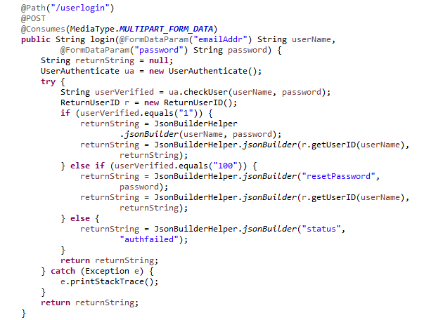

**Generating Menu-Based Suggestions Powered by ECLAT Algorithm:**

Following code snippet takes a transactions and minimum support to calculate the frequent itemsets. Before starting the process, a memory instance is set and timer is started which enables to calculate the memory consumed and time taken for itemset generation. Then the arrylist of integers is parsed and stored on the memory for further calculations. Then the transactions are passed to runAlgorithm method which begins the processing of the algorithm.

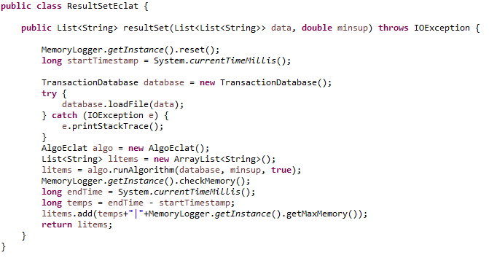

Following code snippet extracts the transactions and stores in a global ArryList. Method ‘loadFile’ parses the list and puts the data into array of string and then the ‘addTransaction’ method puts this array of strings into global list which is an active object.

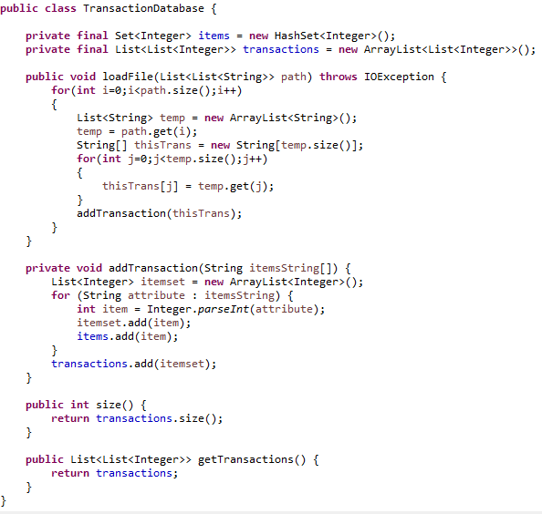

Then the method ‘runAlgorithm’ is called initially puts the data into hashmap so that it can create Triangular matrix to construct the prefix tree. Using the given tidset, it inserts single valued itemsets into triangular matrix whose support is greater than minimum support. Then these single valued itemsets are sort accordingly for further processing. This is a one-time scan on the database. Further, we don’t need scans on the database to calculate the support. Following code snippet show this functionality.

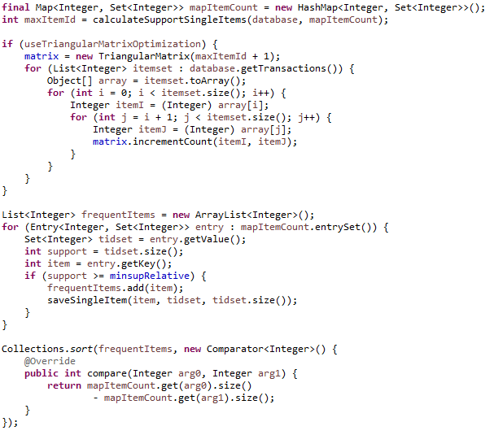

Next candidate itemsets are generated and added to the prefix tree and the support for each of the candidate itemset is calculated using intersection of single valued itemsets. Following code snippet iterates until the all the candidates itemsets are created and checks for support greater than minimum support. Method ‘performAND’ plays crucial role to calculate the intersection operation. Finally, the patterns stored in the list is returned to the requested webservice.

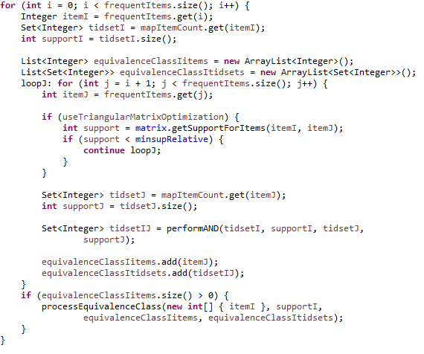

**Code Snippet for Android application:**

Following code snippet shows a sample code of android application development which creates the home page of our project.

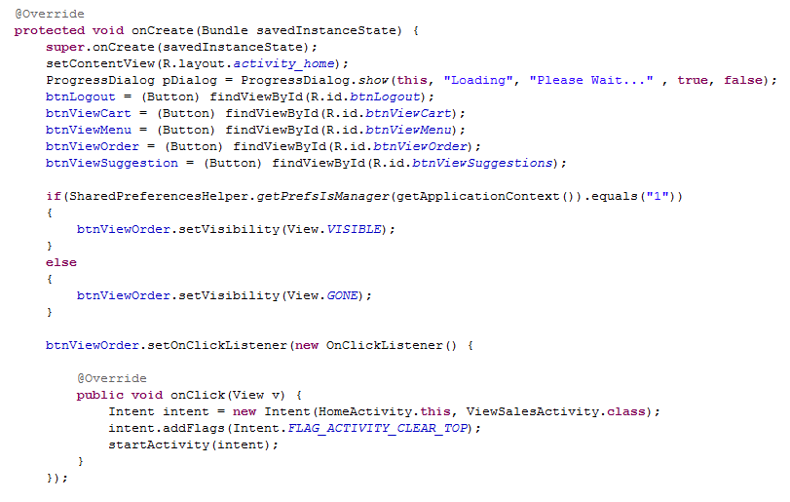

# Results

Above section elaborated on how this application works. With that knowledge, here in this section I would shows the end results and screenshots of entire application. Since android application is accessible to the end user, all the results in this section would be android screenshots.

**Login Page:**

When the application is opened on a tab, the end user sees following screen which asks for email and password to login. If the end user is the existing customer or manager, he can login with his/her credentials or if the new customer or manager uses this app, he/she has to create a new account using ‘Signup Now’ button on the link.

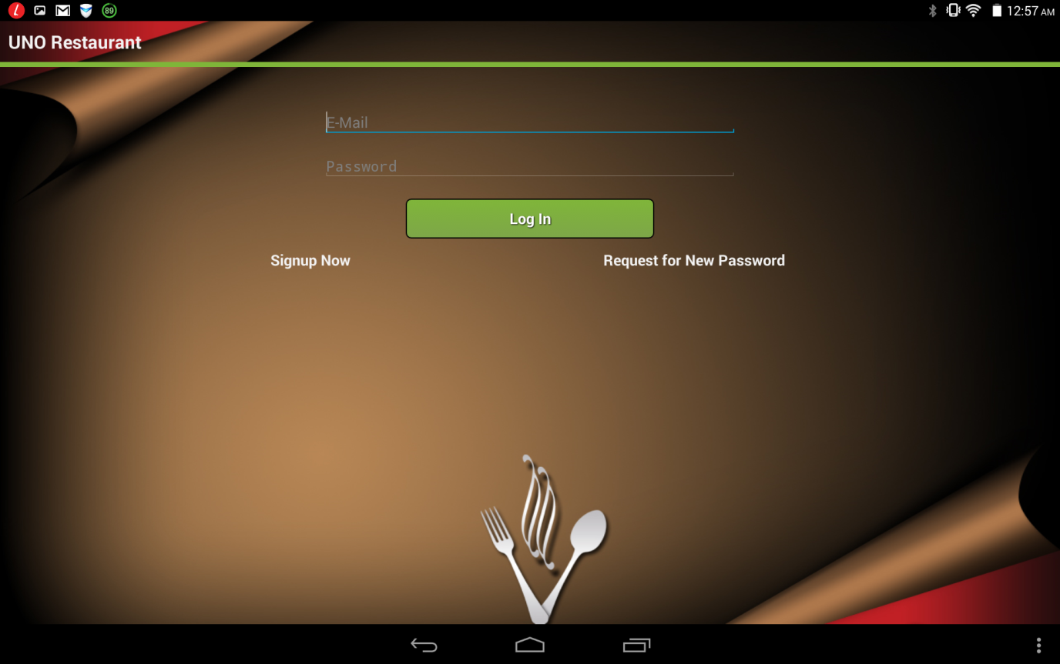

**Create Account:**

When a new user want to create an account, he will be directed to followed page, where is he needs to enter Email, First Name, Last Name, Address, City, State, Phone Number. Once when the user clicks submit, an automatic random password is generated and sent to the email provided in this screen. This page will be automatically redirected to login page when an account is created.

If a created account is manager, then contact database administrator to update this user to manager mode.

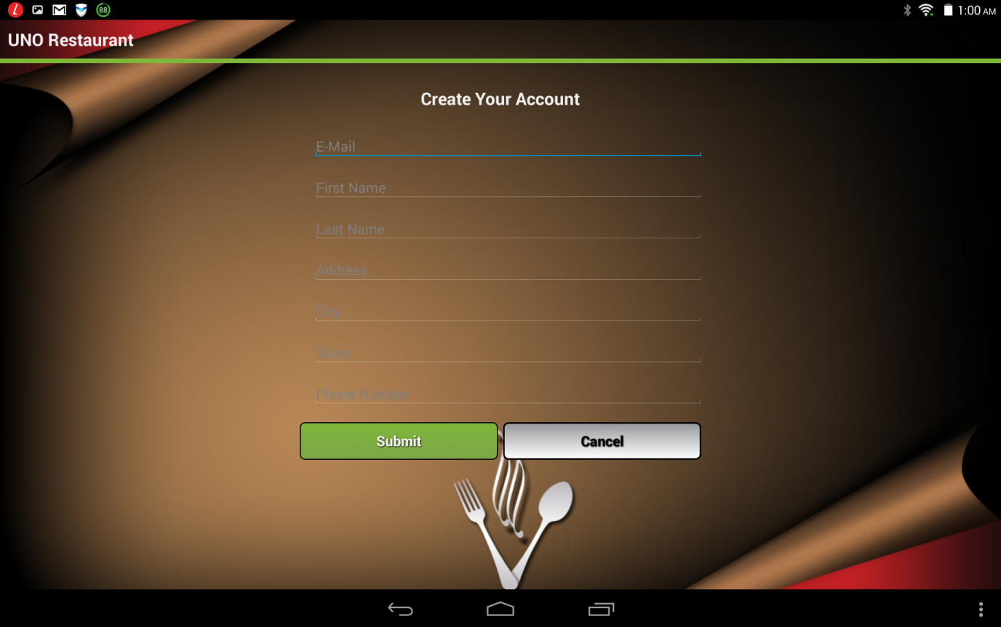

**Forget Password:**

If an existing user forgets his/her password, he can use request for new password on the login screen mentioned above to redirect to below page. Here user has to provide his/her email address and when he hits the submit button, a random password is generated and replaced with existing password. The default password is again sent to the email provided here.

This page will automatically redirect to login where the user has to login with the default password.

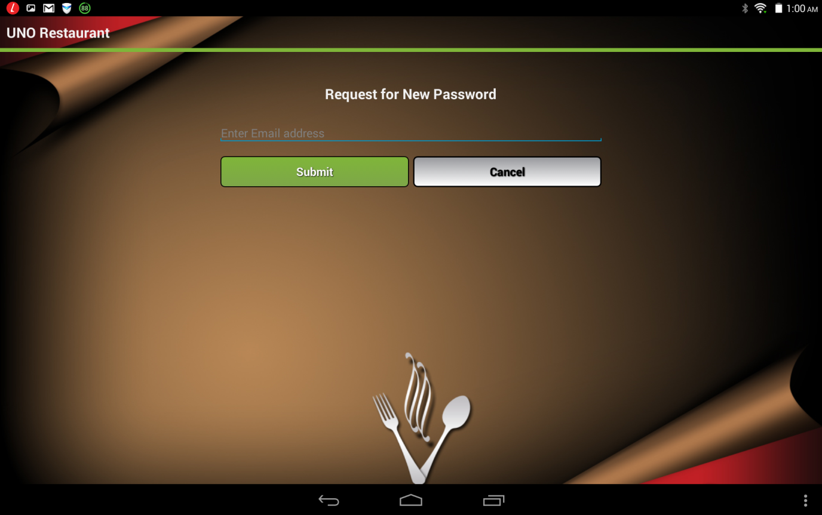

**Change password:**

When a user tries to login with the default password generated by system, it pops up with a dialog box to change the default password. User has to enter old password and a new password to reset the old password. When the user finished with this action, app lands on to the home screen which can be user mode or manager mode.

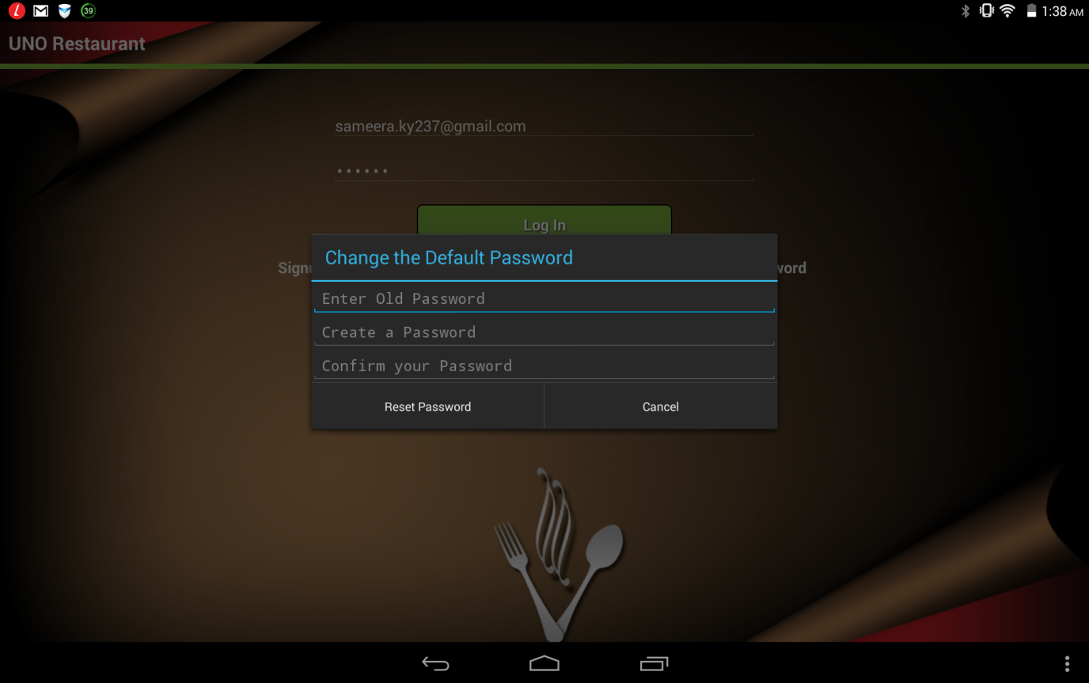

**Home Page:**

When the user logs into the application, he/she lands to following page which is considered as homepage. It contains different options to perform different tasks.

* View Menu option is enabled to both customer and manager mode to see the list of menu items restaurant serves.
* View Cart option is also enable to both customer and manager mode to see the cart and manage the menu items within the cart.
* View Pending orders is only visible to managers who can complete the pending orders placed by customers.
* View Suggestions is enabled to both managers and customers who can view the frequent itemsets generated by ECLAT algorithm.
* Finally, Logout button allows to go out of the application.

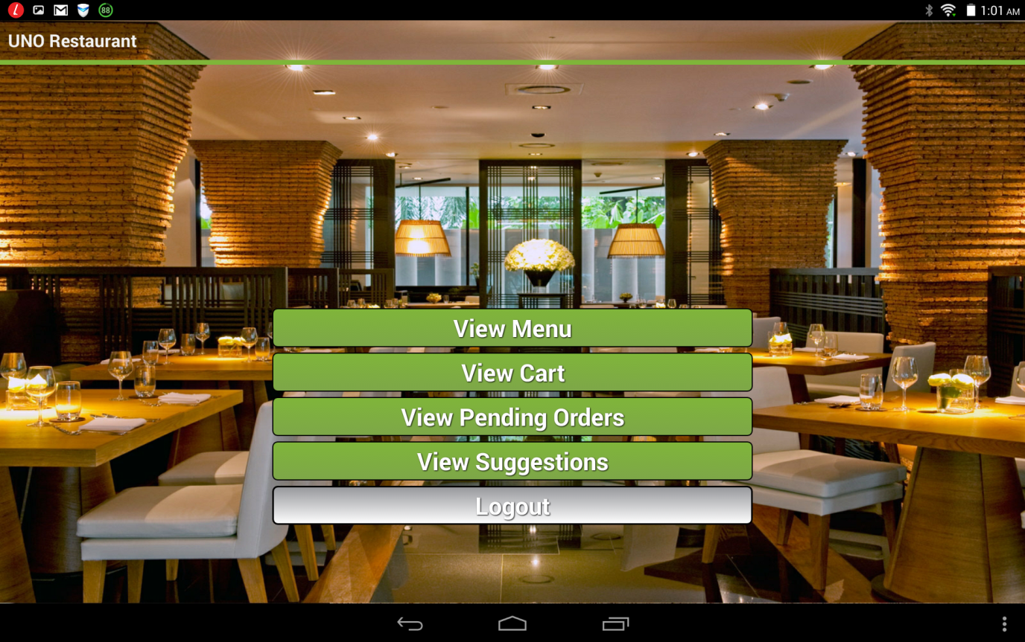

**View Menu Option:**

When a user wants to see the menu items, he lands to following page where he can see the list of the menu items available in the database. Details like item name, category, price are provided to the end user.

* Add to cart button is used to add any of the menu to the cart for checkout. When a user wants to add any of the menu items to cart, it prompts for ‘quantity’ to order that item.
* Enable/Disable buttons are only available in manager mode, where the manager can change the availability of the menu item to the customer.
* Edit buttons are only available in manager mode which facilitates the editing of an item name, category and price.
* Finally, Add new item button is only available in manager mode to add new menu items to the database.

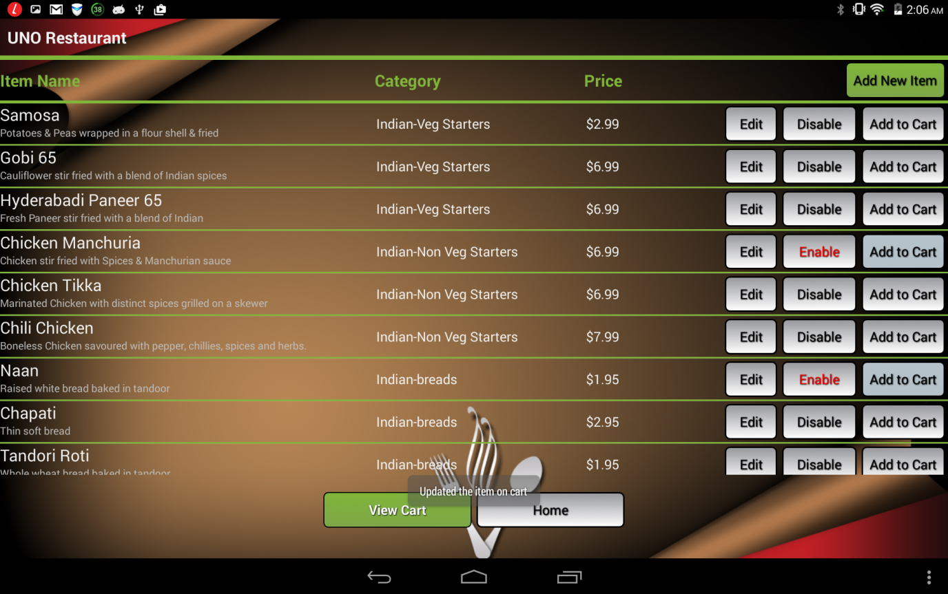

**Add new menu item:**

When manager hits add new item in the previous screen, he/she lands to following page which facilitates adding new menu items. When a new item is added to the database, initially it would be in a disable mode where manager has go to the menu item and enable it whenever the item is ready for customers.

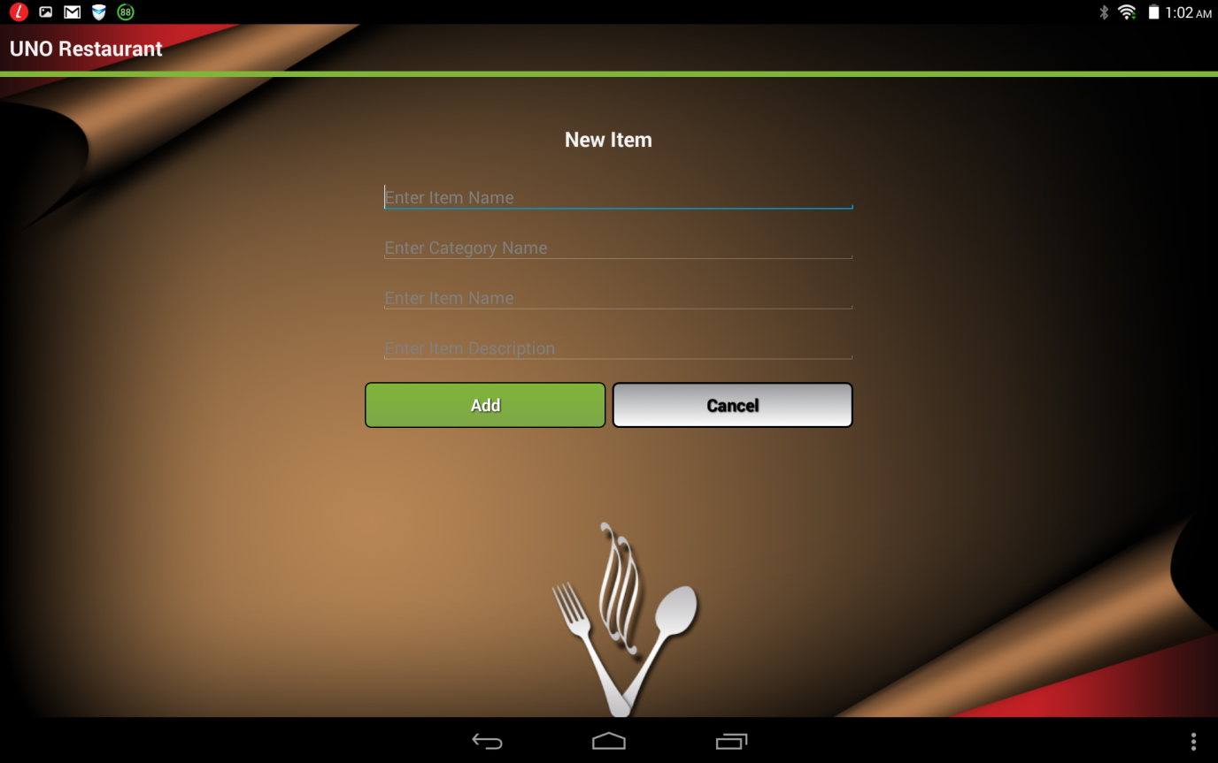

**View cart:**

When a customer or manager views his cart, he is redirected to following page which shows the name, price, quantity subtotal for each item added to cart. Additionally order total would be displayed at the bottom of the screen. Once when the user is ready to order the menu, he can use checkout order button to submit the order.

Add new button will redirect to menu where you can still order other menu items.

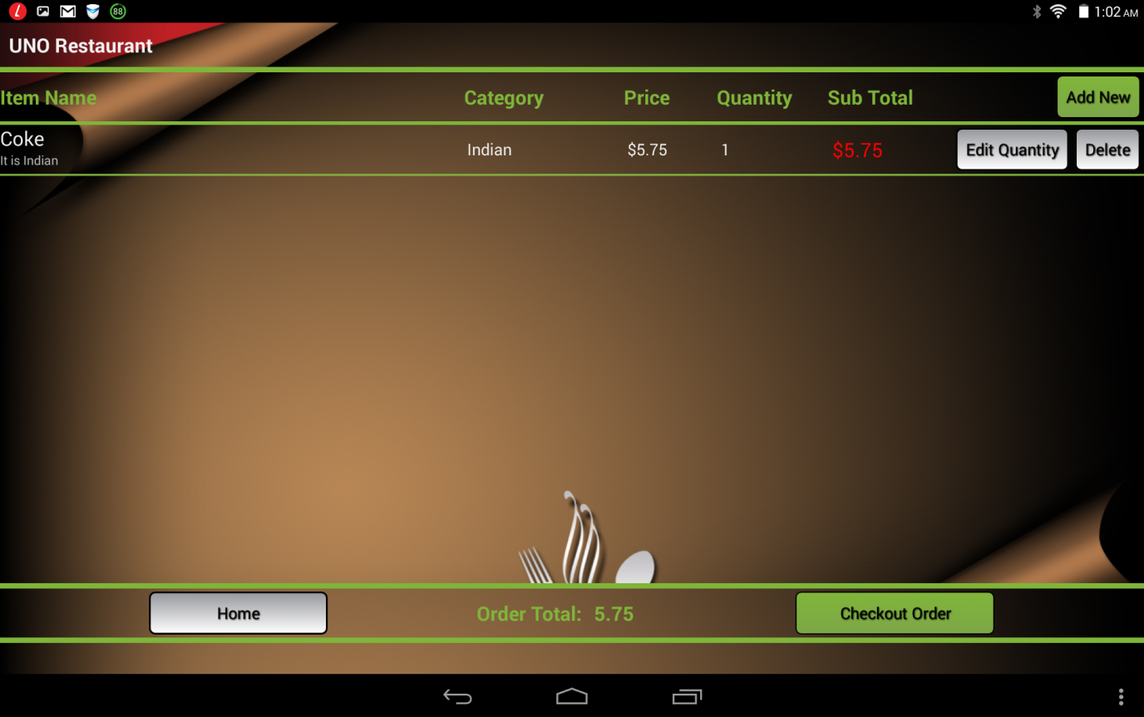

**View Pending Orders:**

This facility is only available to managers, where he can view the orders places along with the time and number of items ordered. If the list grows, manager can track the number of orders placed using Total pending orders button. Also, ‘View Details’ options takes to the detailed order view where we can see all the menu items ordered and quantity.

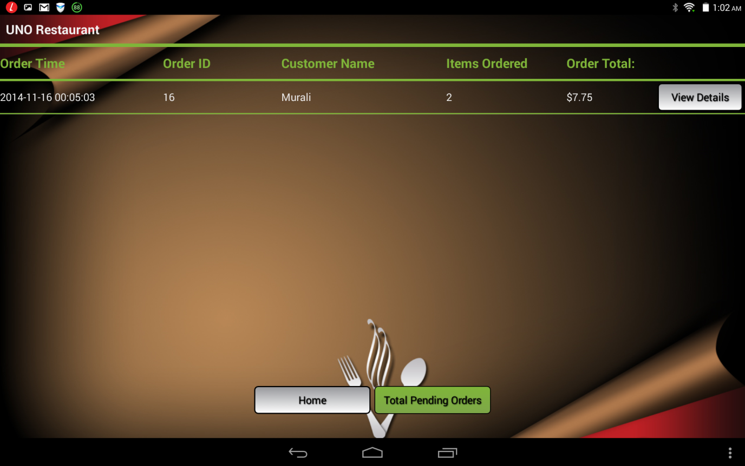

**View detailed order:**

This screen shows the detailed order of a customer where Order ID, Item name, Price, Quantity are showed to the manager.

Apart from the above information, manager can see the order total and bill the customer accordingly and finally complete the order using Complete Order button.

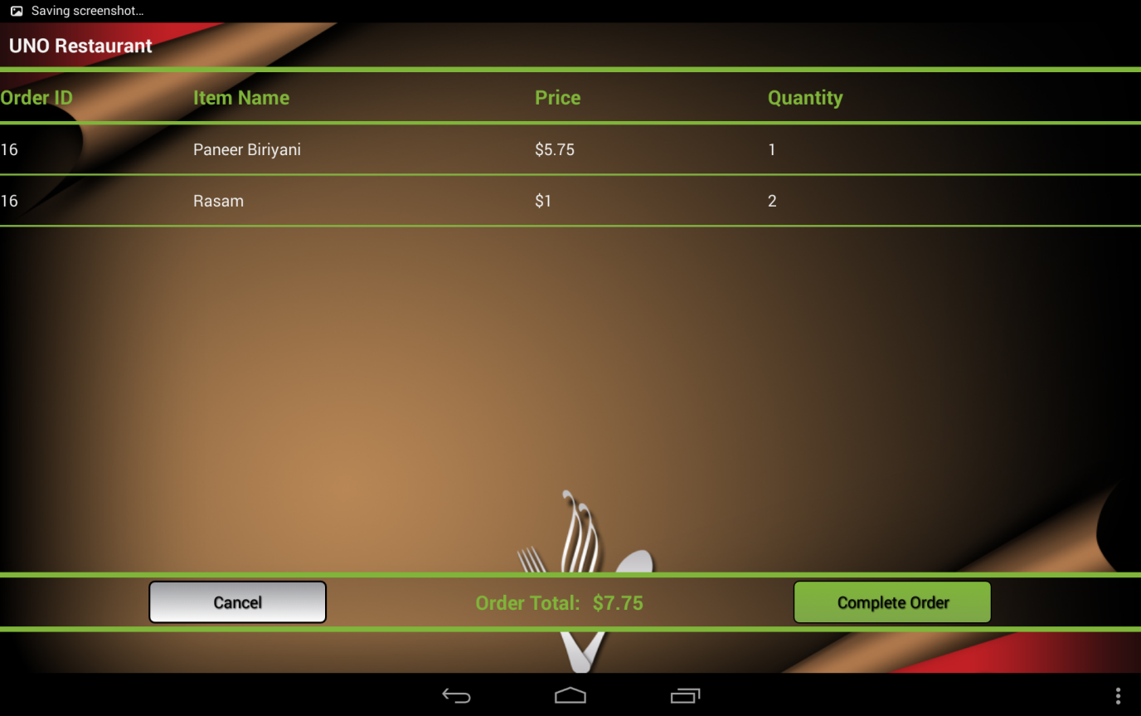

**Frequent patterns selection options:**

When the customer or manager wants to see the frequent patterns or favorites, he or she needs to go to View suggestions option which redirects to following screen.

* Customer has to select the support which is a seeker bar set to 50% by default. Support is frequency of occurrence of pattern in all the transactions.
* Additionally, customers or manager has to select date range so that they can limit the sales between particular dates.
* When the user hits Get suggestions, he/she will be able to see all the frequent patterns.

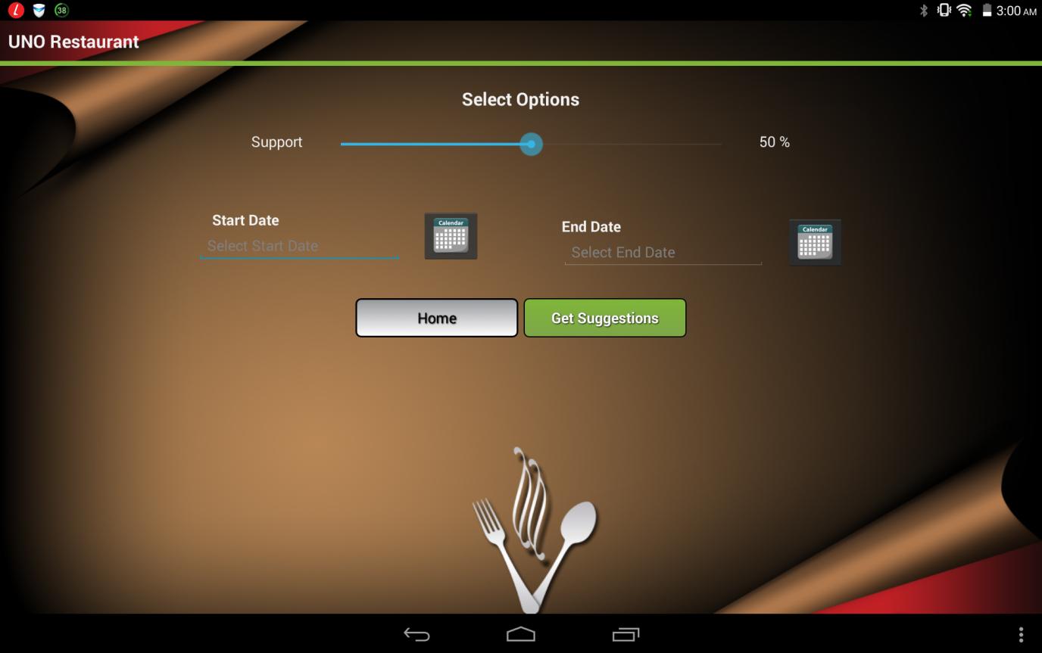

**Calendar selection:**

Data selection is very easy in the selecting the options. A calendar is display when the user hits a calendar button and he can scroll the dates as shown in the following screen.

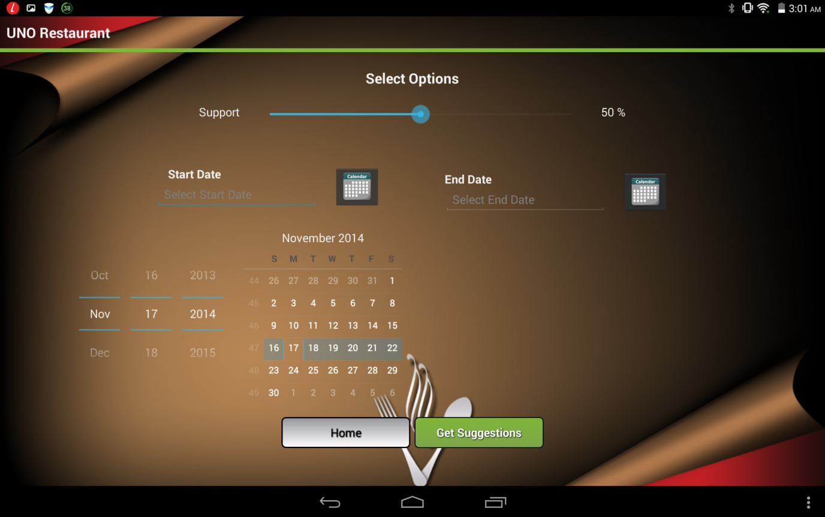

**View Menu-Based Suggestions:**

This is the crucial result of our project. Customers can view the menu-based suggestions based on the selection options. Since there isn’t much data available, I created some test sample which can get the results. Following screen shows the patterns like Coke and Chicken Biriyani is one of the favorite food patterns. Customers can go to the menu using Show Menu option to add these items to the carts.

Also, time taken and memory consumed for calculating menu-based suggestions are displayed on the screen.

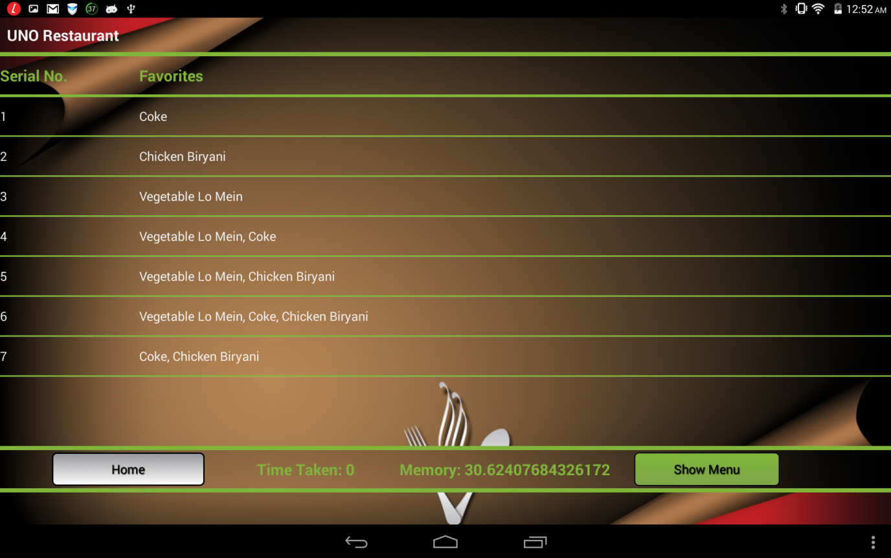

# Limitations

Though I have stressed upon the need for menu-based suggestions using ECLAT algorithm, like how every application comes with a price, so does this. When a restaurant is a new establishment with absolutely no customer transactions, it becomes difficult for the data mining algorithm to scan the almost empty database for frequent item sets. When interesting trends and patterns in the transactional database cannot be homed in on, it becomes obvious that it will create a bottleneck in understanding marketing/sales data and flashing menu suggestions. This leads us to the most obvious conclusion that there is no way for the customer base to use this intelligent POS application to receive food-based suggestions. The menu-suggesting software works best only after a significant size of transactions piles up over time.

Another challenge might come up when this feature is implemented by small businesses whose menu items are volatile and keep varying. With frequent new additions and deletions of item sets, the algorithm faces obstacles in locating frequent patterns or interesting trends among item sets. If a restaurant is a relatively small one with frequent changes to the menu and assuming that many new food items are time and again added to and deleted from the restaurant’s menu. When this happens, there are no adequate transactions done on the new items and all the transactions made on a deleted food item are of no use for recording patterns. The menu suggesting add-on works best for established organizations with minimal changes to the item sets as the transactions are built over time for the almost same item sets and the patterns recorded are more credible.

# Development Environment

For this project I used various technologies to achieve the required functionality for the frond end which is visible to end user and back end which are hidden processes.

On the backend, the ECLAT algorithm which is masked in the JBoss server is developed using Java J2EE and is stored the OpenShift server. Webservices are also developed using J2EE. Database is designed and developed in MySQL and the MySQL-JDBC connector is used communicate between webservices and database.

Also, I installed Eclipse IDE for Java EE Developers to develop code for the backend and Openshift plugin by Red Hat is used to push the code on to the server. Additionally, phpMyAdmin is added as plugin to the Openshift server to access and manage the database.

On the frontend, Eclipse ADT with Android SDK is installed the client machine to develop android application.

# Future Work

With a restricted timeline for development of the application, there a few areas of improvement I could identify for making the application more sophisticated. I list them down here:

1. My project largely dealt with unearthing menu-based suggestions for customers belonging to the restaurant industry. More efforts in finding out other businesses that can absorb this technique and serve their respective customers better can be made and finally association rule mining can be used to accomplish suggestions for these businesses as well.
2. Menu-based suggestions in this project have been achieved using ECLAT algorithm. As a future task, implementing these menu suggestions using equally renowned algorithms like Apriori and FP-growth and comparison of their efficiencies can be taken up.
3. Another potential improvement can be inclusion of voice into the menu-based suggestions. For e.g., when a customer adds a food item into the cart, a voice-based pop-up with menu suggestions can be accommodated.

# Conclusion

As mentioned before, point-of-sale applications in the world of business come with innumerable features alongside the ability of billing customers. My project limited its ambit to the realm of point-of-sale applications in restaurants. The goal of my project was to fill a gap in the present day point-of-sale applications in restaurants that is currently lacking the skill of presenting “menu-based suggestions” to customers. These menu-based suggestions help customers in choosing food items and also in presenting to them a list of widely appreciated food combinations.

In order to fill this “gap” of presenting “menu-based suggestions” to customers, I sought help from the notion of association rule mining and integrated ECLAT algorithm into POS applications to derive frequent item set patterns from the transactional database.

I developed an Android application that can be injected into tablets at restaurants and that pops up suggestions on foods and beverages to customers. This application can as well indicate to managers about foods that were a hit among customers and those which were not really received well by customers.

Upon successful implementation of my project, I can vouch for the fact that deriving menu-based suggestions using an association mining algorithm (ECLAT) is very much possible and the suggestions received are categorically credible.

Such a feature of displaying “menu-based suggestions” to customers at a restaurant has never been in usage anywhere as there has been no proper resources (books or internet) supporting the existence of such a feature. This makes my project on   
“menu-based suggestions” an innovative achievement.

In conclusion, I believe this project has been an intellectual adventure as it has a humungous academic value attached to it. The concepts and ideas I imbibed by taking up the coursework in fulfilment of my master’s program have been a great source of knowledge and motivation to finish the project.

While I believe that my project is an innovative application that is not in usage anywhere, I also admit the fact that there is room for improvement and additions to make the application impeccable.

# Reference

[1] Zaki, Mohammed Javeed. "Scalable algorithms for association mining." Knowledge and Data Engineering, IEEE Transactions on 12.3 (2000): 372-390.

[2] Saxena, A., & Gadhiya, S (2014). A Survey on Frequent Pattern Mining Methods Apriori, Eclat, FP growth. C.U. Shah College of Engineering and Technology.

[3] S Vijayarani and P Sathya. Article: Mining Frequent Item Sets over Data Streams using Eclat Algorithm. IJCA Proceedings on International Conference on Research Trends in Computer Technologies 2013 ICRTCT(4):27-31, February 2013

[4] Zaki, M. J., & Meira Jr, W. (2014). Data Mining and Analysis: Fundamental Concepts and Algorithms. Cambridge University Press

[5] Burnette, E. (2009). Hello, Android: introducing Google's mobile development platform. Pragmatic Bookshelf

[6] Xuguang, H. (2009). An Introduction to Android. Dababase Lab. Inha Univeristy.

[7] Ansel, D., & Dyer, C. (1999). A framework for restaurant information technology. Cornell Hotel and Restaurant Administration Quarterly, 40(3), 74-84. Retrieved from http://search.proquest.com/docview/209706830?accountid=14692

[8] Berry, M. J., & Linoff, G. (1997). Data mining techniques: for marketing, sales, and customer support. John Wiley & Sons, Inc..

[9] Han, J., Pei, J., & Yin, Y. (2000, May). Mining frequent patterns without candidate generation. In ACM SIGMOD Record (Vol. 29, No. 2, pp. 1-12). ACM.

[10] Malhis, N., Ruttan, A., & Refai, H. H. (2005). An Efficient Approach for Candidate Set Generation. Journal of Information & Knowledge Management, 4(04), 287-291.

[11] Agrawal, R., Imielinski, T., & Swami, A. (1993, June). Mining association rules between sets of items in large databases. In ACM SIGMOD Record (Vol. 22, No. 2, pp. 207-216). ACM.

[12] Hidber, C. (1999). Online association rule mining (Vol. 28, No. 2, pp. 145-156). ACM.

Purdom, P. W., Van Gucht, D., & Groth, D. P. (2004). Average-case performance of the apriori algorithm. SIAM Journal on Computing, 33(5), 1223-1260.

[13] Hills, J., Bagnall, A., de la Iglesia, B., & Richards, G. (2013). BruteSuppression: a size reduction method for Apriori rule sets. Journal of intelligent information systems, 40(3), 431-454.

[14] Reynolds, A., & de la Iglesia, B. (2006). Rule induction using multi-objective metaheuristics: Encouraging rule diversity. In International joint conference on neural networks, 2006. IJCNN’06. (pp 3343–3350). IEEE

[15] Gebhardt, F. (1991). Choosing among competing generalizations. Knowledge Acquisition, 3(4), 361–380

[16] Al-Maolegi, M., & Arkok, B. (2014). An Improved Apriori Algorithm for Association Rules. arXiv preprint arXiv:1403.3948.

[17] S. Rao, R. Gupta, “Implementing Improved Algorithm Over APRIORI Data Mining Association Rule Algorithm”, International Journal of Computer Science And Technology, pp. 489-493, Mar. 2012

[18] X. Wu, V. Kumar, J. Ross Quinlan, J. Ghosh, Q. Yang, H. Motoda, G. J. McLachlan, A. Ng, B. Liu, P. S. Yu, Z.-H. Zhou, M. Steinbach, D. J. Hand, and D. Steinberg, “Top 10 algorithms in data mining,” Knowledge and Information Systems, vol. 14, no. 1, pp. 1–37, Dec. 2007.

[19] Borgelt, C. (2005, August). An Implementation of the FP-growth Algorithm. In Proceedings of the 1st international workshop on open source data mining: frequent pattern mining implementations (pp. 1-5). ACM.

[20] Jones, M., & Palvia, G. (2004). U.S. Patent Application 10/779,803.